Part 1:
Task 1.1:
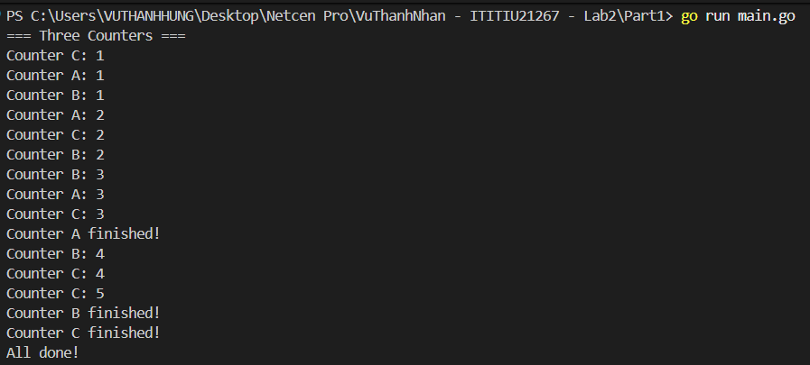

Task 1.2:
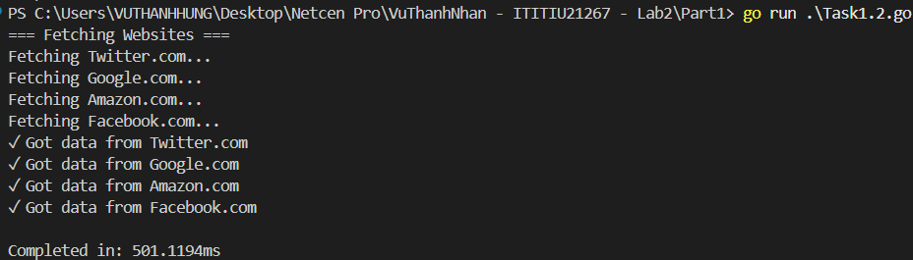

Part 2:
Task 2.1:
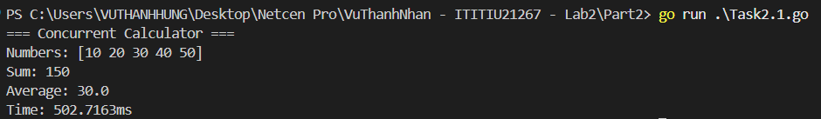

Task 2.2:
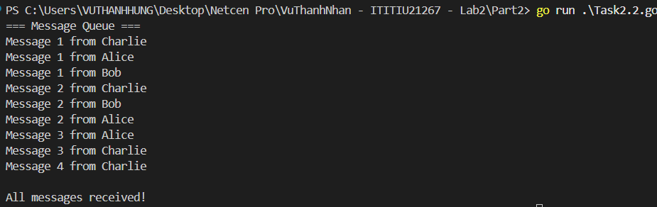

Part 3:
Task 3.1:
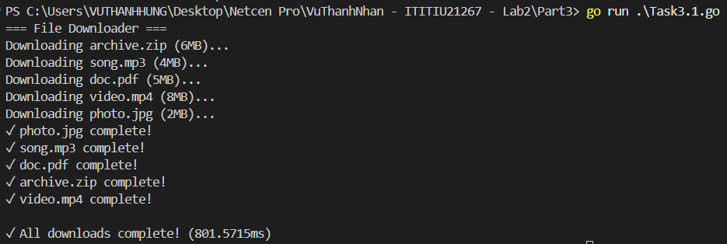

Task 3.2:
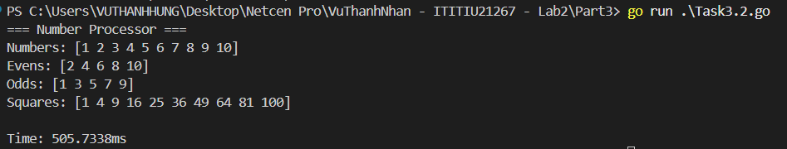

Part 4:
Task 4.1:
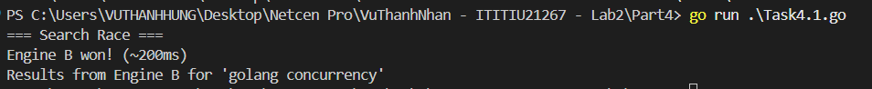

Part 5:
Task 5.1:
